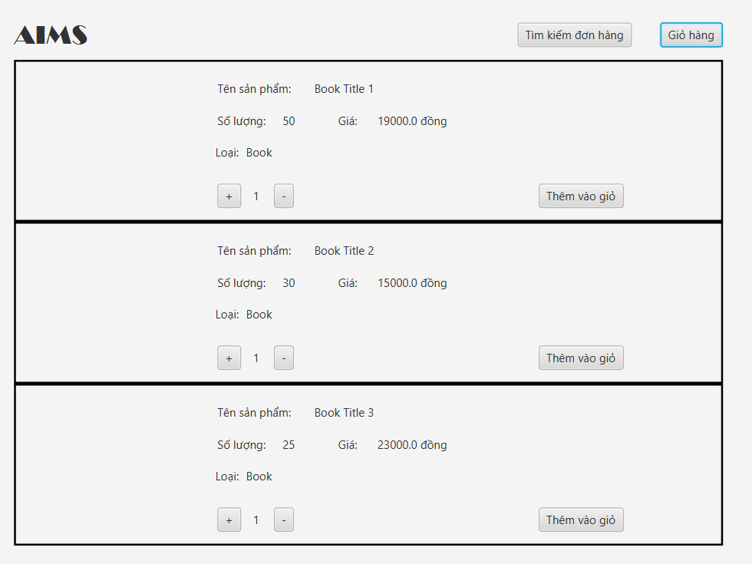

**Home Screen Specification**

| **Screen Element** | **Control** | **Operation** | **Function** |
| --- | --- | --- | --- |
| Product List | Interactive List | Scrolling/Clicking | Display products available for purchase |
| Quantity Selector | Input Field/Button | Writing/Clicking | Select the quantity of the product |
| Add to Cart Button | Button | Clicking | Add the selected quantity of product to the cart |

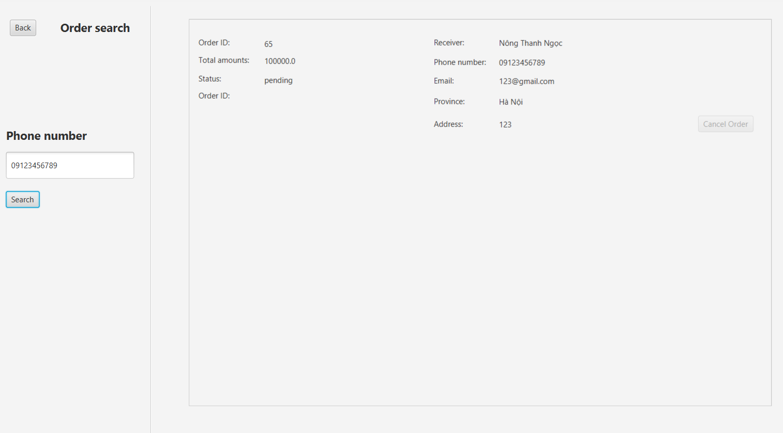

**Order Search Screen Specification**

| **Screen Element** | **Control** | **Operation** | **Function** |
| --- | --- | --- | --- |
| Phone Number Field | Text Field | Writing | Enter a phone number to search for orders |
| Search Button | Button | Clicking | Initiate search for orders associated with the phone number |

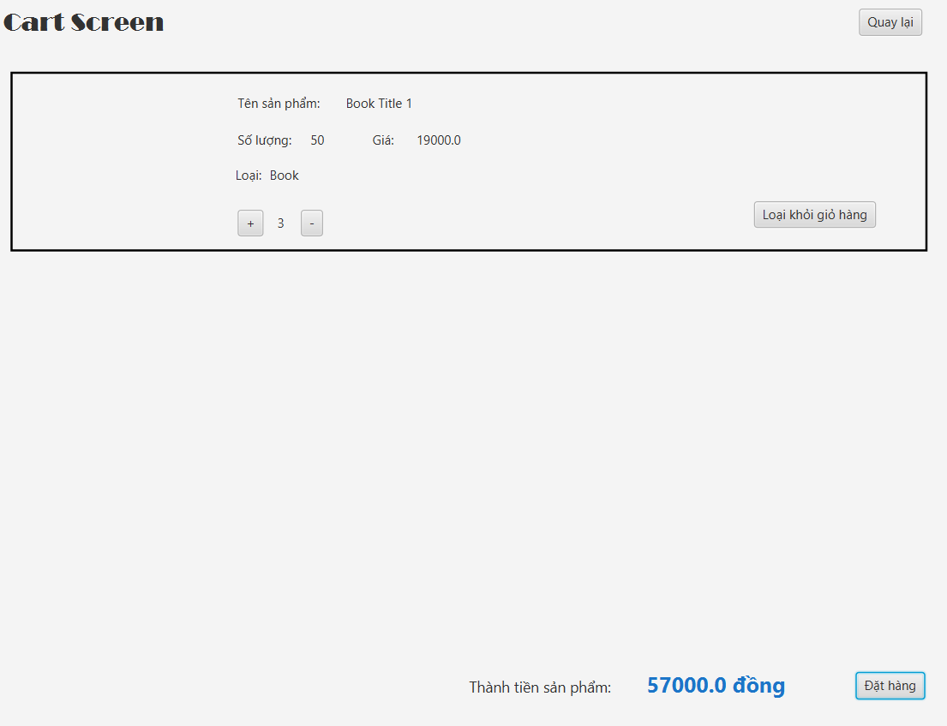

**Cart Screen Specification**

| **Screen Element** | **Control** | **Operation** | **Function** |
| --- | --- | --- | --- |
| Item List | Interactive List | Display | Show items added to the cart |
| Quantity Selector | Input Field/Button | Writing/Clicking | Adjust the quantity of a cart item |
| Remove Item Button | Button | Clicking | Remove an item from the cart |
| Total Price | Label | Display | Show the total price of items in the cart |
| Checkout Button | Button | Clicking | Proceed to the checkout process |

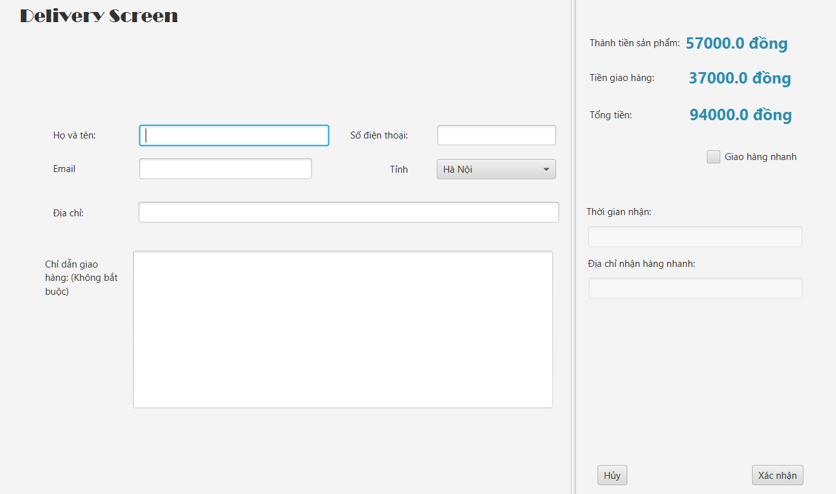

**Delivery Screen Specification**

| **Screen Element** | **Control** | **Operation** | **Function** |
| --- | --- | --- | --- |
| Recipient Name Field | Text Field | Writing | Enter the name of the recipient for delivery |
| Address Field | Text Field | Writing | Enter the delivery address |
| Delivery Options | Checkbox/Dropdown | Selecting/Toggling | Choose delivery options and services |

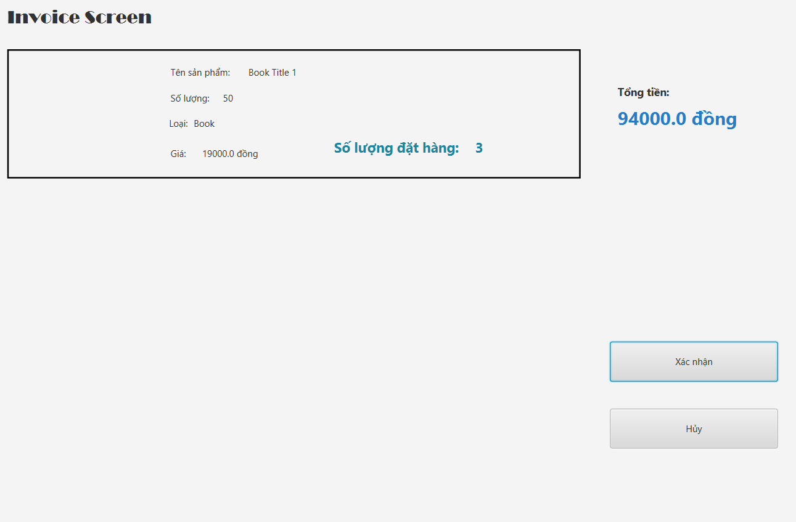

**Invoice Screen Specification**

| **Screen Element** | **Control** | **Operation** | **Function** |
| --- | --- | --- | --- |
| Itemized List | Interactive List | Display | Show a list of purchased items with prices |
| Total Amount | Label | Display | Display the total amount due |
| Confirm Payment Button | Button | Clicking | Confirm the purchase and proceed to payment |

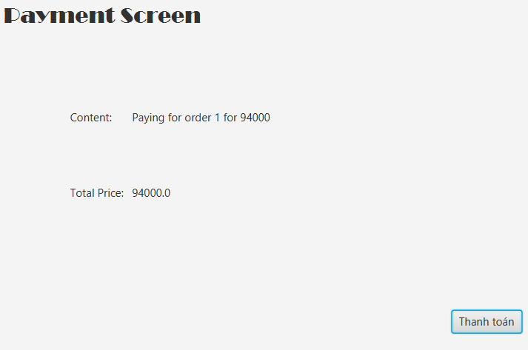

**Payment Screen Specification**

| **Screen Element** | **Control** | **Operation** | **Function** |
| --- | --- | --- | --- |
| Total Price | Label | Display | Show the total price to be paid |
| Payment Button | Button | Clicking | Initiate the payment process |

**Payment Result Screen Specification**

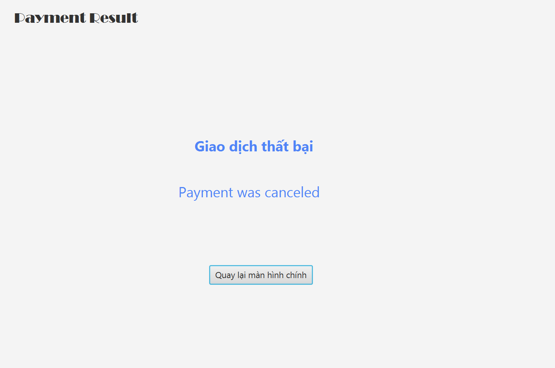

| **Screen Element** | **Control** | **Operation** | **Function** |
| --- | --- | --- | --- |
| Failure Message | Label | Display | Show that the payment process was canceled |
| Return Home Button | Button | Clicking | Navigate back to the main screen |